## Implementing SVM and Kernel SVM with Python's Scikit-Learn

*By*[*Usman Malik*](https://twitter.com/usman_malikk)*• April 17, 2018 •*[*7 Comments*](https://stackabuse.com/implementing-svm-and-kernel-svm-with-pythons-scikit-learn/#disqus_thread)

A [support vector machine](https://en.wikipedia.org/wiki/Support_vector_machine) (SVM) is a type of supervised machine learning classification algorithm. SVMs were introduced initially in 1960s and were later refined in 1990s. However, it is only now that they are becoming extremely popular, owing to their ability to achieve brilliant results. SVMs are implemented in a unique way when compared to other machine learning algorithms.

In this article we'll see what support vector machines algorithms are, the brief theory behind support vector machine and their implementation in Python's Scikit-Learn library. We will then move towards an advanced SVM concept, known as Kernel SVM, and will also implement it with the help of Scikit-Learn.

### Simple SVM

In case of linearly separable data in two dimensions, as shown in Fig. 1, a typical machine learning algorithm tries to find a boundary that divides the data in such a way that the misclassification error can be minimized. If you closely look at Fig. 1, there can be several boundaries that correctly divide the data points. The two dashed lines as well as one solid line classify the data correctly.

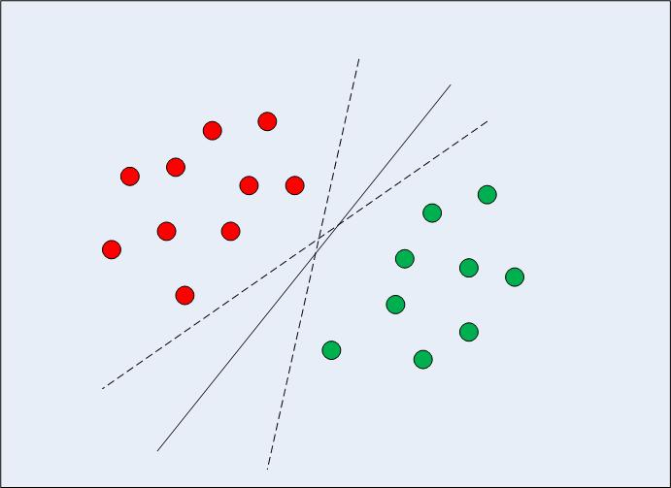

Fig 1: Multiple Decision Boundaries

SVM differs from the other classification algorithms in the way that it chooses the [decision boundary](https://en.wikipedia.org/wiki/Decision_boundary) that maximizes the distance from the nearest data points of all the classes. An SVM doesn't merely find a decision boundary; it finds the most optimal decision boundary.

The most optimal decision boundary is the one which has maximum margin from the nearest points of all the classes. The nearest points from the decision boundary that maximize the distance between the decision boundary and the points are called support vectors as seen in Fig 2. The decision boundary in case of support vector machines is called the maximum margin classifier, or the maximum margin hyper plane.

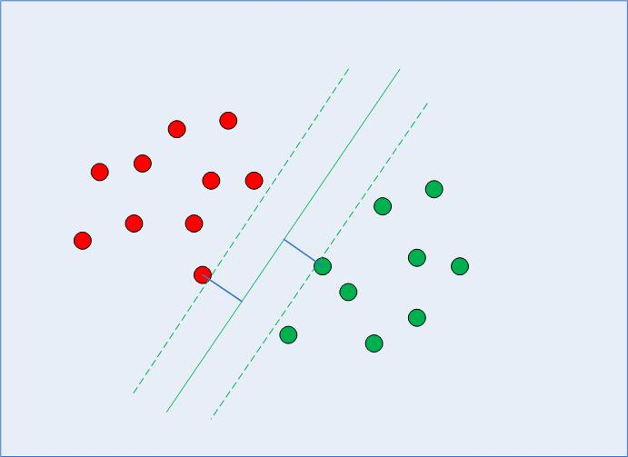

Fig 2: Decision Boundary with Support Vectors

There is complex mathematics involved behind finding the support vectors, calculating the margin between decision boundary and the support vectors and maximizing this margin. In this tutorial we will not go into the detail of the mathematics, we will rather see how SVM and Kernel SVM are implemented via the Python Scikit-Learn library.

### Implementing SVM with Scikit-Learn

The dataset that we are going to use in this section is the same that we used in the classification section of the [decision tree tutorial](https://stackabuse.com/decision-trees-in-python-with-scikit-learn/).

Our task is to predict whether a bank currency note is authentic or not based upon four attributes of the note i.e. skewness of the wavelet transformed image, variance of the image, entropy of the image, and curtosis of the image. This is a binary classification problem and we will use SVM algorithm to solve this problem. The rest of the section consists of standard machine learning steps.

#### Importing libraries

The following script imports required libraries:

import pandas as pd

import numpy as np

import matplotlib.pyplot as plt

%matplotlib inline

#### Importing the Dataset

The data is available for download at the following link:

<https://drive.google.com/file/d/13nw-uRXPY8XIZQxKRNZ3yYlho-CYm_Qt/view>

The detailed information about the data is available at the following link:

<https://archive.ics.uci.edu/ml/datasets/banknote+authentication>

Download the dataset from the Google drive link and store it locally on your machine. For this example the CSV file for the dataset is stored in the "Datasets" folder of the D drive on my Windows computer. The script reads the file from this path. You can change the file path for your computer accordingly.

To read data from CSV file, the simplest way is to use read_csv method of the pandas library. The following code reads bank currency note data into pandas dataframe:

bankdata = pd.read_csv("D:/Datasets/bill_authentication.csv")

#### Exploratory Data Analysis

There are virtually limitless ways to analyze datasets with a variety of Python libraries. For the sake of simplicity we will only check the dimensions of the data and see first few records. To see the rows and columns and of the data, execute the following command:

bankdata.shape

In the output you will see (1372,5). This means that the bank note dataset has 1372 rows and 5 columns.

To get a feel of how our dataset actually looks, execute the following command:

bankdata.head()

The output will look like this:

|  | **Variance** | **Skewness** | **Curtosis** | **Entropy** | **Class** |
| --- | --- | --- | --- | --- | --- |
| 0 | 3.62160 | 8.6661 | -2.8073 | -0.44699 | 0 |
| 1 | 4.54590 | 8.1674 | -2.4586 | -1.46210 | 0 |
| 2 | 3.86600 | -2.6383 | 1.9242 | 0.10645 | 0 |
| 3 | 3.45660 | 9.5228 | -4.0112 | -3.59440 | 0 |
| 4 | 0.32924 | -4.4552 | 4.5718 | -0.98880 | 0 |

You can see that all of the attributes in the dataset are numeric. The label is also numeric i.e. 0 and 1.

#### Data Preprocessing

Data preprocessing involves (1) Dividing the data into attributes and labels and (2) dividing the data into training and testing sets.

To divide the data into attributes and labels, execute the following code:

X = bankdata.drop('Class', axis=1)

y = bankdata['Class']

In the first line of the script above, all the columns of the bankdata dataframe are being stored in the X variable except the "Class" column, which is the label column. The drop() method drops this column.

In the second line, only the class column is being stored in the y variable. At this point of time X variable contains attributes while y variable contains corresponding labels.

Once the data is divided into attributes and labels, the final preprocessing step is to divide data into training and test sets. Luckily, the model_selection library of the Scikit-Learn library contains the train_test_split method that allows us to seamlessly divide data into training and test sets.

Execute the following script to do so:

from sklearn.model_selection import train_test_split

X_train, X_test, y_train, y_test = train_test_split(X, y, test_size = 0.20)

#### Training the Algorithm

We have divided the data into training and testing sets. Now is the time to train our SVM on the training data. Scikit-Learn contains the svm library, which contains built-in classes for different SVM algorithms. Since we are going to perform a classification task, we will use the support vector classifier class, which is written as SVC in the Scikit-Learn's svm library. This class takes one parameter, which is the kernel type. This is very important. In the case of a simple SVM we simply set this parameter as "linear" since simple SVMs can only classify linearly separable data. We will see non-linear kernels in the next section.

The fit method of SVC class is called to train the algorithm on the training data, which is passed as a parameter to the fit method. Execute the following code to train the algorithm:

from sklearn.svm import SVC

svclassifier = SVC(kernel='linear')

svclassifier.fit(X_train, y_train)

#### Making Predictions

To make predictions, the predict method of the SVC class is used. Take a look at the following code:

y_pred = svclassifier.predict(X_test)

#### Evaluating the Algorithm

Confusion matrix, precision, recall, and F1 measures are the most commonly used metrics for classification tasks. Scikit-Learn's metrics library contains the classification_report and confusion_matrix methods, which can be readily used to find out the values for these important metrics.

Here is the code for finding these metrics:

from sklearn.metrics import classification_report, confusion_matrix

print(confusion_matrix(y_test,y_pred))

print(classification_report(y_test,y_pred))

#### Results

The evaluation results are as follows:

[[152 0]

[ 1 122]]

precision recall f1-score support

0 0.99 1.00 1.00 152

1 1.00 0.99 1.00 123

avg / total 1.00 1.00 1.00 275

#### Subscribe to our Newsletter

Top of Form

Get occassional tutorials, guides, and reviews in your inbox. No spam ever. Unsubscribe at any time.

Subscribe

Bottom of Form

From the results it can be observed that SVM slightly outperformed the decision tree algorithm. There is only one misclassification in the case of SVM algorithm compared to four misclassifications in the case of the decision tree algorithm.

### Kernel SVM

In the previous section we saw how the simple SVM algorithm can be used to find decision boundary for linearly separable data. However, in the case of non-linearly separable data, such as the one shown in Fig. 3, a straight line cannot be used as a decision boundary.

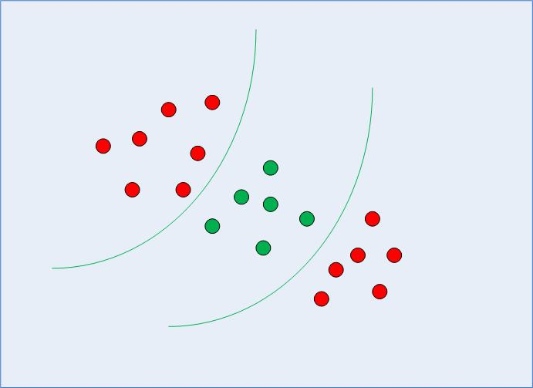

Fig 3: Non-linearly Separable Data

In case of non-linearly separable data, the simple SVM algorithm cannot be used. Rather, a modified version of SVM, called Kernel SVM, is used.

Basically, the kernel SVM projects the non-linearly separable data lower dimensions to linearly separable data in higher dimensions in such a way that data points belonging to different classes are allocated to different dimensions. Again, there is complex mathematics involved in this, but you do not have to worry about it in order to use SVM. Rather we can simply use Python's Scikit-Learn library that to implement and use the kernel SVM.

### Implementing Kernel SVM with Scikit-Learn

Implementing Kernel SVM with Scikit-Learn is similar to the simple SVM. In this section, we will use the famous [iris dataset](https://en.wikipedia.org/wiki/Iris_flower_data_set) to predict the category to which a plant belongs based on four attributes: sepal-width, sepal-length, petal-width and petal-length.

The dataset can be downloaded from the following link:

<https://archive.ics.uci.edu/ml/datasets/iris4>

The rest of the steps are typical machine learning steps and need very little explanation until we reach the part where we train our Kernel SVM.

#### Importing Libraries

import numpy as np

import matplotlib.pyplot as plt

import pandas as pd

#### Importing the Dataset

url = "https://archive.ics.uci.edu/ml/machine-learning-databases/iris/iris.data"

*# Assign colum names to the dataset*

colnames = ['sepal-length', 'sepal-width', 'petal-length', 'petal-width', 'Class']

*# Read dataset to pandas dataframe*

irisdata = pd.read_csv(url, names=colnames)

#### Preprocessing

X = irisdata.drop('Class', axis=1)

y = irisdata['Class']

#### Train Test Split

from sklearn.model_selection import train_test_split

X_train, X_test, y_train, y_test = train_test_split(X, y, test_size = 0.20)

#### Training the Algorithm

To train the kernel SVM, we use the same SVC class of the Scikit-Learn's svm library. The difference lies in the value for the kernel parameter of the SVC class. In the case of the simple SVM we used "linear" as the value for the kernel parameter. However, for kernel SVM you can use Gaussian, polynomial, sigmoid, or computable kernel. We will implement polynomial, Gaussian, and sigmoid kernels to see which one works better for our problem.

#### 1. Polynomial Kernel

In the case of [polynomial kernel](https://en.wikipedia.org/wiki/Polynomial_kernel), you also have to pass a value for the degree parameter of the SVC class. This basically is the degree of the polynomial. Take a look at how we can use a polynomial kernel to implement kernel SVM:

from sklearn.svm import SVC

svclassifier = SVC(kernel='poly', degree=8)

svclassifier.fit(X_train, y_train)

#### Making Predictions

Now once we have trained the algorithm, the next step is to make predictions on the test data.

Execute the following script to do so:

y_pred = svclassifier.predict(X_test)

#### Evaluating the Algorithm

As usual, the final step of any machine learning algorithm is to make evaluations for polynomial kernel. Execute the following script:

from sklearn.metrics import classification_report, confusion_matrix

print(confusion_matrix(y_test, y_pred))

print(classification_report(y_test, y_pred))

The output for the kernel SVM using polynomial kernel looks like this:

[[11 0 0]

[ 0 12 1]

[ 0 0 6]]

precision recall f1-score support

Iris-setosa 1.00 1.00 1.00 11

Iris-versicolor 1.00 0.92 0.96 13

Iris-virginica 0.86 1.00 0.92 6

avg / total 0.97 0.97 0.97 30

Now let's repeat the same steps for Gaussian and sigmoid kernels.

#### 2. Gaussian Kernel

Take a look at how we can use polynomial kernel to implement kernel SVM:

from sklearn.svm import SVC

svclassifier = SVC(kernel='rbf')

svclassifier.fit(X_train, y_train)

To use Gaussian kernel, you have to specify 'rbf' as value for the Kernel parameter of the SVC class.

#### Prediction and Evaluation

y_pred = svclassifier.predict(X_test)

from sklearn.metrics import classification_report, confusion_matrix

print(confusion_matrix(y_test, y_pred))

print(classification_report(y_test, y_pred))

The output of the Kernel SVM with Gaussian kernel looks like this:

[[11 0 0]

[ 0 13 0]

[ 0 0 6]]

precision recall f1-score support

Iris-setosa 1.00 1.00 1.00 11

Iris-versicolor 1.00 1.00 1.00 13

Iris-virginica 1.00 1.00 1.00 6

avg / total 1.00 1.00 1.00 30

#### 3. Sigmoid Kernel

Finally, let's use a sigmoid kernel for implementing Kernel SVM. Take a look at the following script:

from sklearn.svm import SVC

svclassifier = SVC(kernel='sigmoid')

svclassifier.fit(X_train, y_train)

To use the sigmoid kernel, you have to specify 'sigmoid' as value for the kernel parameter of the SVC class.

#### Prediction and Evaluation

y_pred = svclassifier.predict(X_test)

from sklearn.metrics import classification_report, confusion_matrix

print(confusion_matrix(y_test, y_pred))

print(classification_report(y_test, y_pred))

The output of the Kernel SVM with Sigmoid kernel looks like this:

[[ 0 0 11]

[ 0 0 13]

[ 0 0 6]]

precision recall f1-score support

Iris-setosa 0.00 0.00 0.00 11

Iris-versicolor 0.00 0.00 0.00 13

Iris-virginica 0.20 1.00 0.33 6

avg / total 0.04 0.20 0.07 30

#### Comparison of Kernel Performance

If we compare the performance of the different types of kernels we can clearly see that the sigmoid kernel performs the worst. This is due to the reason that sigmoid function returns two values, 0 and 1, therefore it is more suitable for binary classification problems. However, in our case we had three output classes.

Amongst the Gaussian kernel and polynomial kernel, we can see that Gaussian kernel achieved a perfect 100% prediction rate while polynomial kernel misclassified one instance. Therefore the Gaussian kernel performed slightly better. However, there is no hard and fast rule as to which kernel performs best in every scenario. It is all about testing all the kernels and selecting the one with the best results on your test dataset.

Reference:

<https://stackabuse.com/implementing-svm-and-kernel-svm-with-pythons-scikit-learn/>